Environment Sensing Design Notes

In the past, we used ultrasonic distance sensors to get the distance between the RoBee and the environment, is this the best solution, or is there a more reliable method?

We can buy the HC-SR04 ultrasonic sensors for about $4 each on digikey which is a 5 V system. Best rage for use is 10 – 200 cm
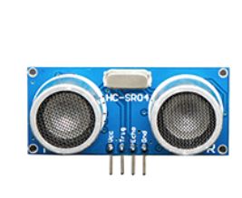

What about the TMF8801? A light based distance sensor for up to 2500 mm which is $4.60.
This is a 3.3 volt compatible system.
More accurate at sub mm ranges.

